Outline:

1. Summary

“You can only cook with what’s in the fridge”. We aim to create a website to aid in the task of home cooking. In a more refined sense, our website is a recipe creation service that allows the user to make efficient use of their existing pantry, whether that be dry or cold ingredients. For the less creatively inclined home cook, drawing up new recipes can be a daunting task, and furthermore, finding recipes that make use of what’s in the fridge adds enough complexity that many people would rather order takeout.

Our website is based around two core features: the recipe creator and the virtual fridge. These features operate symbiotically, with optimal usage resulting in the user making full use of both. How our website functions is we provide the user with a blank virtual fridge, where they will input the contents of their food storages with varying quantities. Such a feature has far more advanced implications, such as the use case of picture recognition, receipt scanning, barcode scanning, or other systems, however, in its most basic state, the virtual fridge serves as a way for the user and our service to know what could *possibly* be on the menu at all times. The recipe creator is able to pick a recipe from the database, where all ingredients are available from the fridge database. Therefore, allowing the user to select a recipe with varying levels of criteria based on what they already have in stock, reducing unnecessary expenditure and food waste. The recipe creator can also be extrapolated into a meal planner service and other features, such as the inclusion of nutritional metrics and dietary specifications.

1. Stakeholders

In a broader sense, anyone with a pantry and a means to cook the ingredients held within it could be a user and stakeholder of Garde Manger. However, we propose Garde Manger with these specific stakeholders in mind: students on a limited meal plan, chefs on a budget, health-conscious individuals, uncreative cooks, overzealous grocery shoppers, and of course, Dr. Callahan and the TAs.

Students on a limited meal plan may have little experience in grocery shopping, managing a pantry, and cooking independently. Between classes and studying, they may find it difficult to learn this new and important skill. Garde Manger's recipe generator can assist them in finding a recipe to cook with the ingredients they bought. The virtual pantry's display of expiration dates can help them ensure they eat their food before it spoils.

The recipe generator's ability to sort recipes by their compatibility with the virtual pantry allows users on a budget to stretch their food dollar by providing recipes with ingredients they have already bought. Additionally, the virtual pantry and shopping list features help these users know what exactly they need to buy, reducing unnecessary spending.

Similar to those on a monetary budget, people monitoring their diet must budget their calories and nutrients for each meal. These users can use the readily available nutritional information in the virtual pantry to help monitor what they eat.

Overzealous grocery shoppers are users who tend to over-buy at the grocery store and struggle to use their food before it expires. These users can use the recipe generator to incorporate a more plentiful ingredient into their dishes in varying ways. Similarly, uncreative cooks who find themselves cooking the same meal every night with the same ingredients may use the recipe generator to find a different meal to cook with those ingredients.

Dr. Callahan and the TAs are very busy working and grading our assignments. The recipe generator will do the heavy lifting on their meal planning and allow for them to spend even more time grading!

1. Technologies

Our project will use all the web technologies we picked up during the intro course. Rudimentarily, we will use HTML and CSS to code and style the pages for our project. They will be used in conjunction with Javascript to make our pages more interactive. Some of our current plans with JS are to have smooth animations for key page elements (i.e. the pantry) and use jQuery UI widgets to display data and alerts on the profile page. In terms of JS, we also plan to use AJAX and our knowledge of XML to create an RSS feed, compiling all of our featured recipes into a JSON for ease of displaying consistent records.

PHP will be the primary language for our backend development - it will be useful in allowing us to dynamically display recipes from our JSON as well as create a secure login system for our user profiles. Regarding user data, PHPMyAdmin will provide us with a GUI to make changes to our MariaDB database; we will create tables in MariaDB (using MySQL) to store user credentials and fridge items. Lastly, throughout the semester, we will utilize GitHub Projects to organize our progress and milestones.

1. Functional & Non-functional Requirements

**Functional Requirements:**

* Recipe database
  + Pulls from a static or evolving recipe database for recipe suggestions based on search criteria.
  + Scrape data from recipe websites (ex: NYT Cooking)
* Ingredients database
  + User creates a database of existing ingredients used for recipe suggestions.
  + Input, add, delete.
* Individualized user profiles
  + Store saved recipes, fridge data, and more data associated with the user.

**Non-functional Requirements:**

* Detailed fridge information
  + Ability to add/remove specific quantities from existing ingredients.
  + Expiry date information.
* User profile functionality
  + Sign up, log in, forget password, family accounts.

1. Site Map & Wireframes

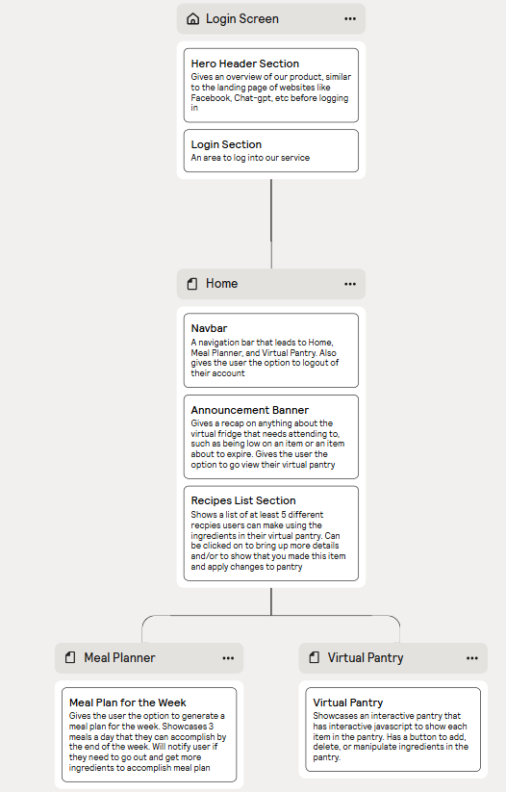

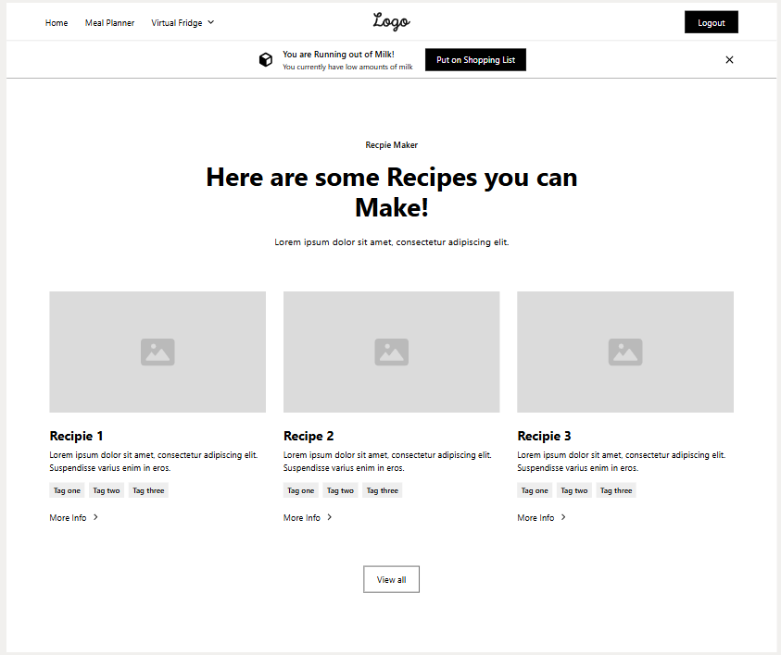

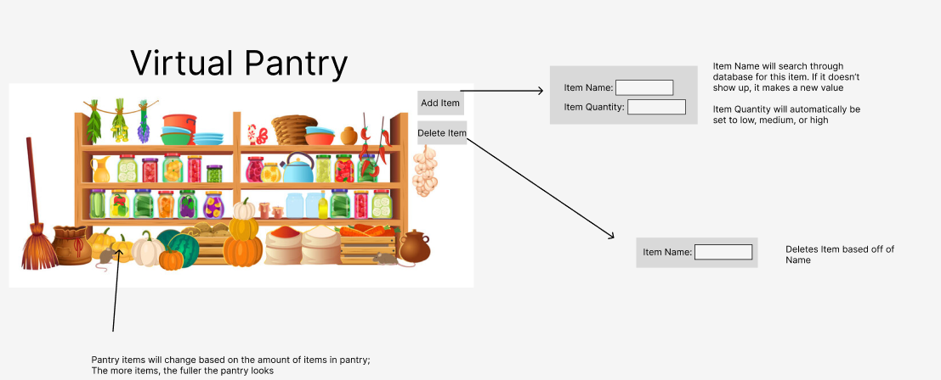

1. Timeline

| **Milestone** | **Status** | **End Date** |
| --- | --- | --- |
| Project proposal | Complete | 9/10 |
| Brand scheming | In progress | 9/17 |
| Pantry back end | Not yet started | 10/1 |
| Recipe generator back end | Not yet started | 10/7 |
| Midterm presentation | Not yet started | 10/25 |
| Pantry front end | Not yet started | 11/1 |
| Recipe generator back end | Not yet started | 11/7 |
| Completed project | Not yet started | 12/6 |